# CS 255 System Design Document Template

This template lays out all the different sections that you need to complete for Project Two. Each section has guidance to prompt your thinking. You will need to continually reference the interview transcript as you work to make sure that you are addressing your client’s needs. There is no required length for the final document. Instead the goal is to complete each section based on what your client’s needs are. Remove this note when you are finished, and replace all bracketed text with the relevant information.

## UML Diagrams

### UML Use Case Diagram

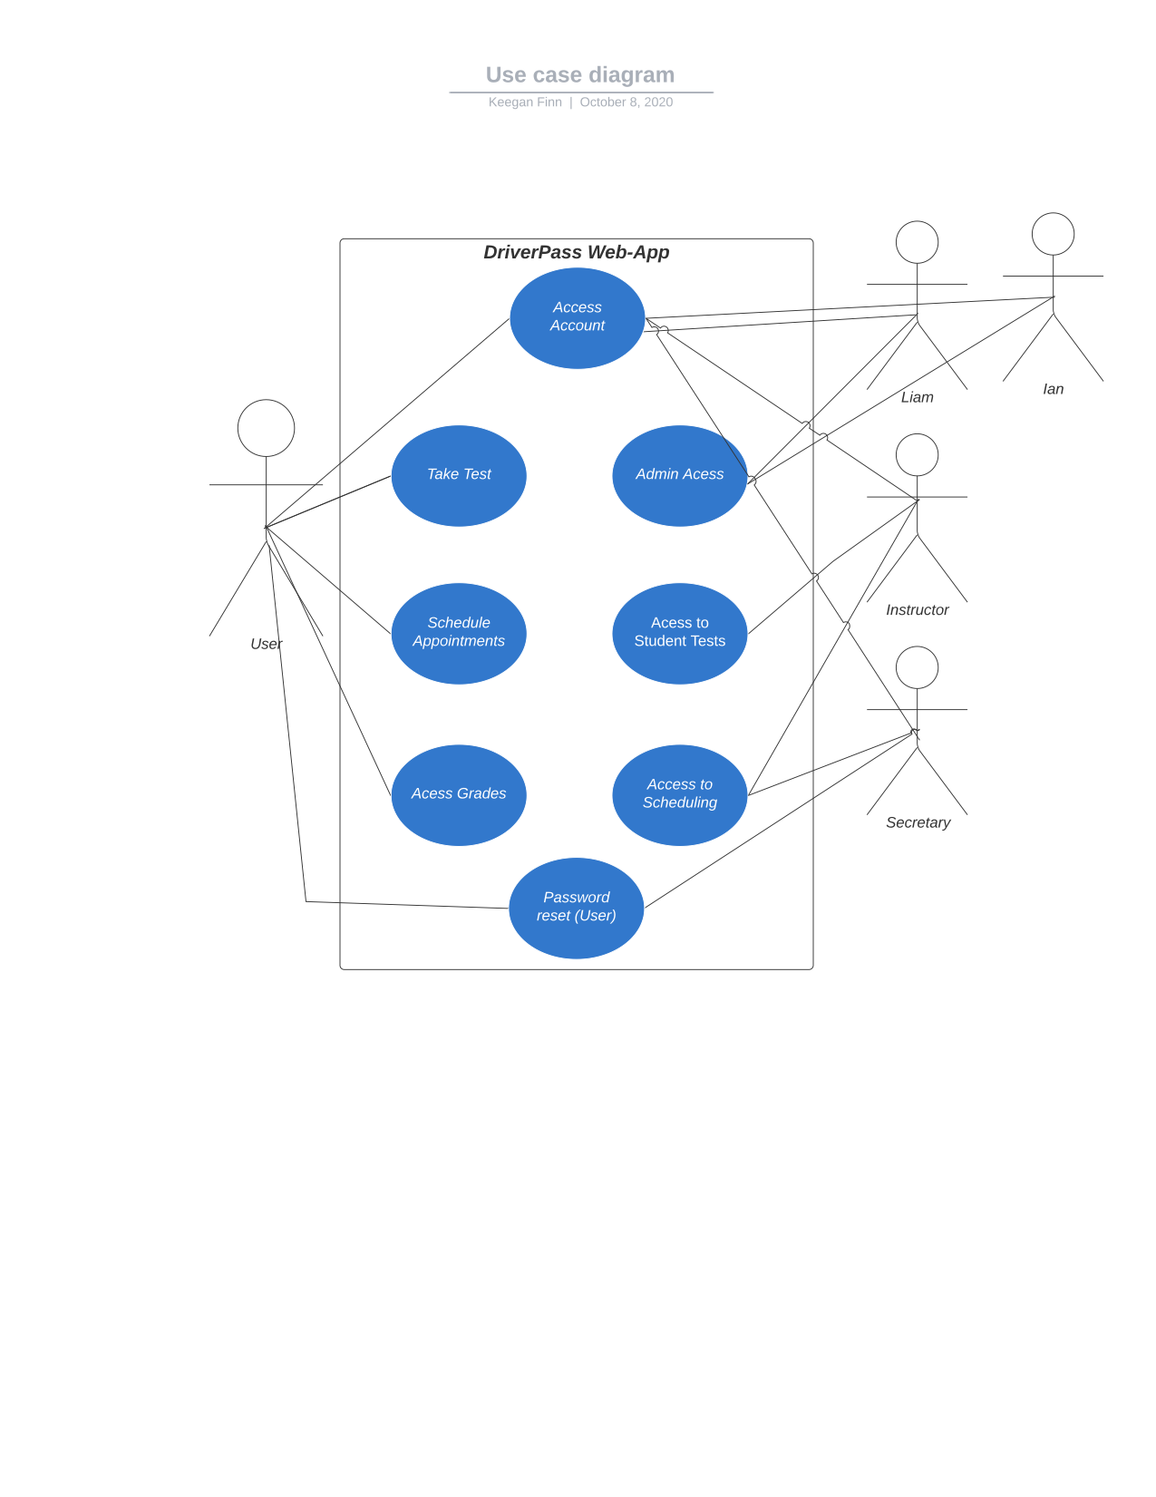

### UML Activity Diagrams

### 

### UML Sequence Diagram

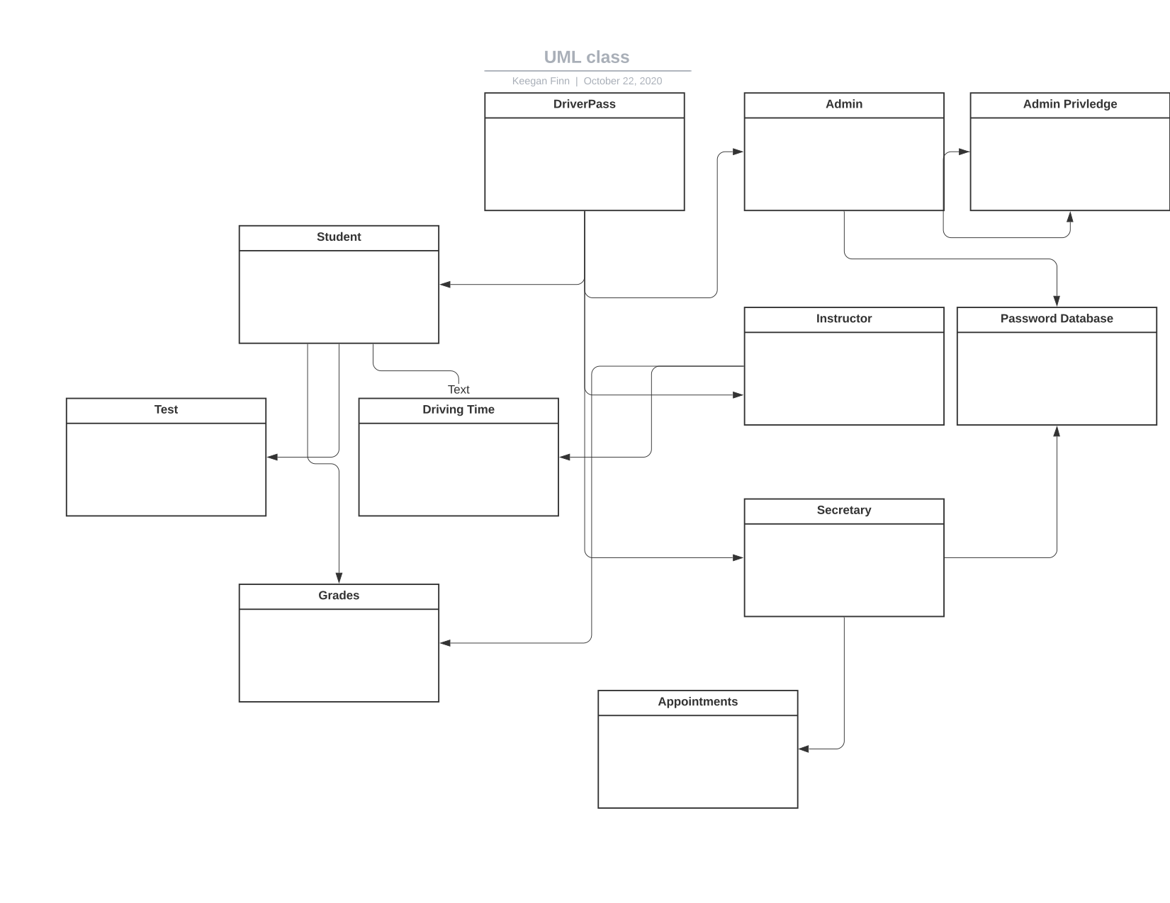

### UML Class Diagram

## Technical Requirements

Based on the design of the DriverPass system I have created, the DriverPass company needs to invest into cloud computing server provider. Not only does the company need to use a server provider, they will also need to be sure that this can be reached from mobile and desktops on different platforms to ensure the broad out reach to potential and current users.

When considering how much computing power the DriverPass company will be renting, the company itself needs to identify the user amount, customers and employees, and as this number increases more server performance will be needed. The DriverPass system will need to have some sort of password protection, such as two factor authentication as well as a password database only accessible by the secretary or the Admin to resolve password issues.

The DriverPass system is set up to easily implement and maintain as long as the required performance of hardware is provided. To maintain or update the system, DriverPass would be much better off outsourcing the work to a developer for new ideas or editing existing features.